**What is Resource Monitor in Snowflake**

A Resource Monitor in Snowflake helps track and control the consumption of compute credits by warehouses to prevent excessive usage. It allows administrators to set thresholds and automatically suspend or notify when usage reaches a defined limit.

By using Resource monitor

* Prevent unexpected credit overages.
* Suspend warehouses when they reach their limit.
* Get notifications when usage is nearing the threshold.
* Automatically resume warehouses when a new billing cycle starts.

Resource monitors can be created using Web UI or SQL commands.

Here created 4 different resource monitors to monitor 4 different warehouses and assigned them to respective Functional roles.

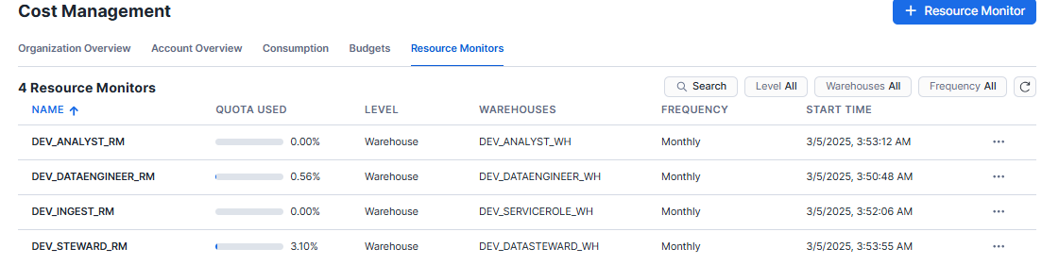

**Key Parameters in Resource Monitor**

**CREDIT QUOTA**

Defines the total number of compute credits a resource monitor can track within a specified period.

If this quota is reached, the assigned warehouses can be suspended to prevent further usage.

**SCHEDULE**

Defines how often the credit usage counter is reset (i.e., how often the limit starts over).

Available options:

DAILY → Resets every day.

WEEKLY → Resets every week.

MONTHLY → Resets every month.

YEARLY → Resets once per year.

NEVER → Credit usage does not reset automatically.

**ACTIONS**

Defines actions to take when a warehouse reaches a percentage of its assigned credit quota.

Options:

NOTIFY → Sends an alert (no action taken).

SUSPEND → Suspends warehouses, but allows running queries to finish.

SUSPEND IMMEDIATE → Immediately stops warehouses and cancels running queries.

**CREATNG RESOURCE MONITOR IN SNOWFLAKE USING WEB UI**

In Snowflake, click on Admin—---> Cost management—----->click on Reosurce Monitor and enter details as per requirement.

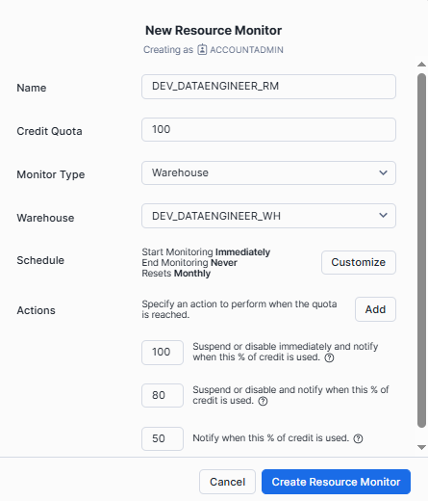

As per above configuration

when DEV_DATAENGINEER_WH reaches 50% usage, an alert is sent.

At 80% usage, warehouses are suspended (after finishing queries).

At 100% usage, warehouses are immediately suspended.

You can also definer multiple actions at different percentages by clicking on Add button